Testing document

1. HTML Validation

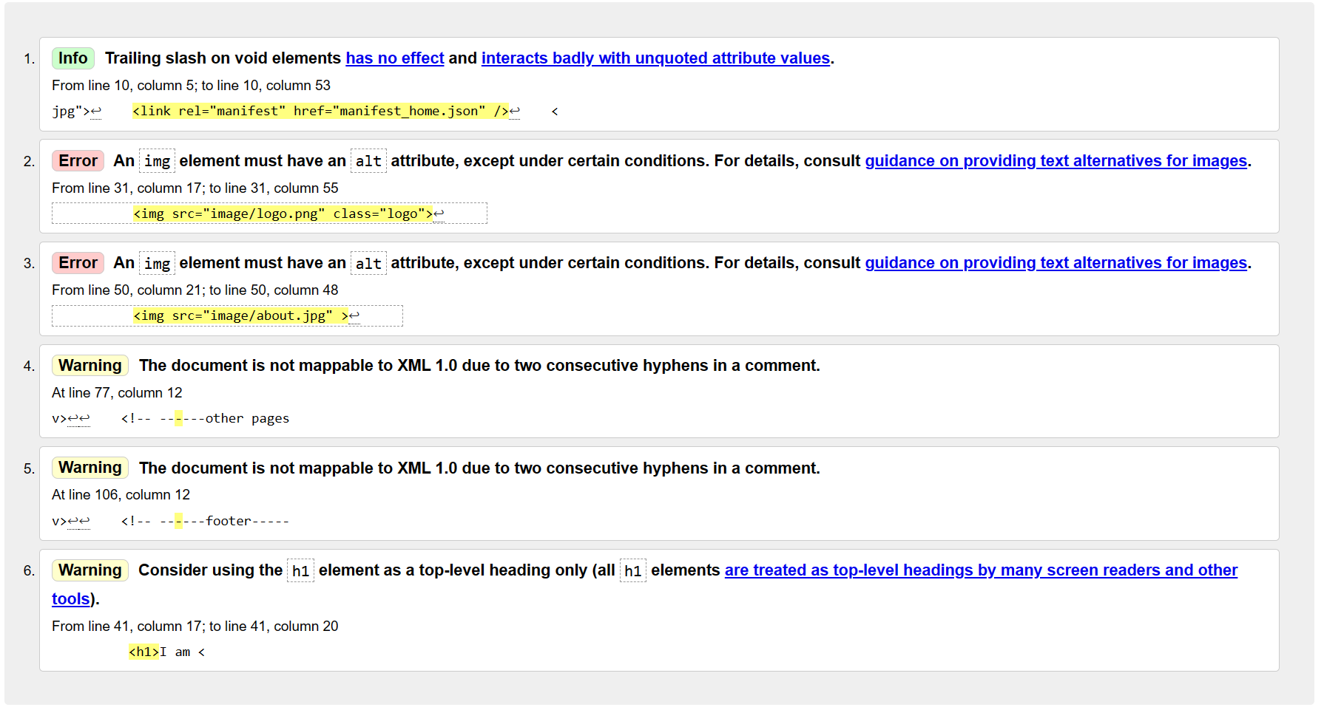

1. CSS Validation

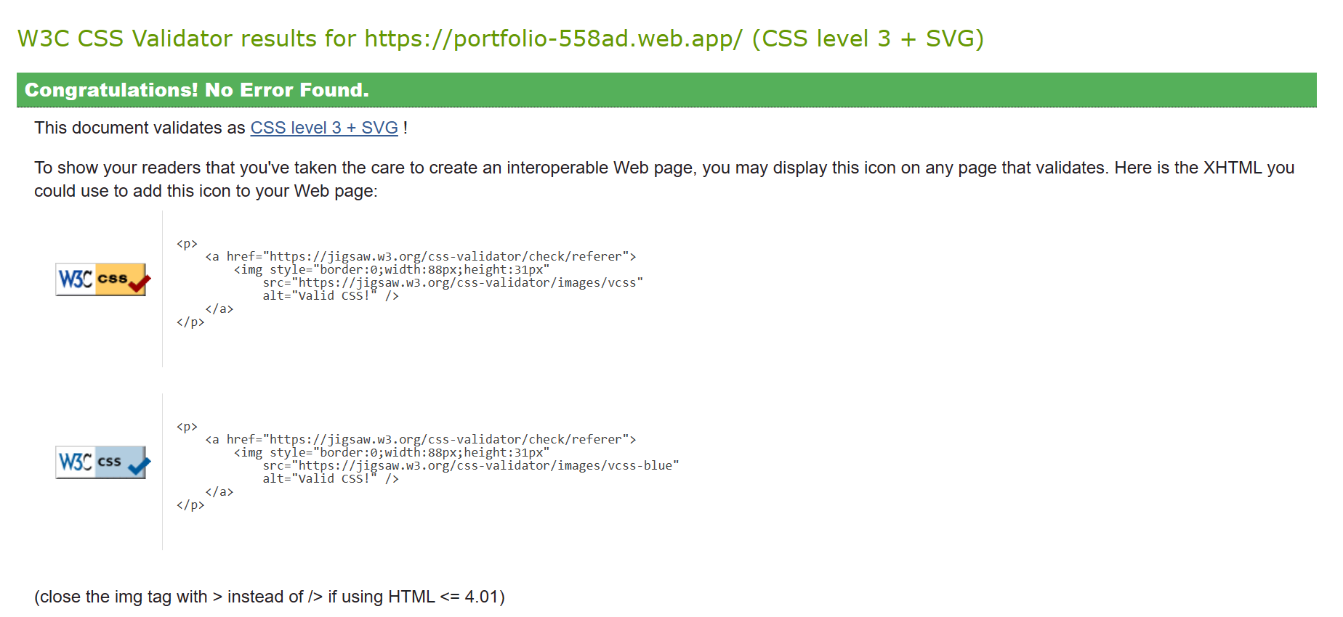

1. Lighthouse testing

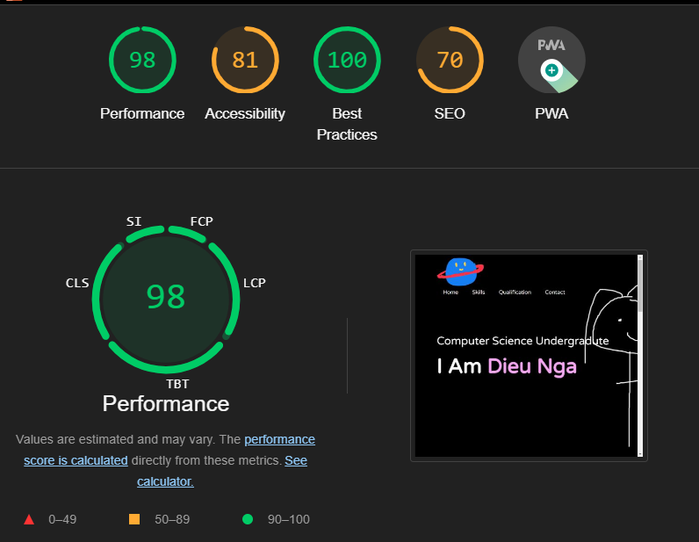

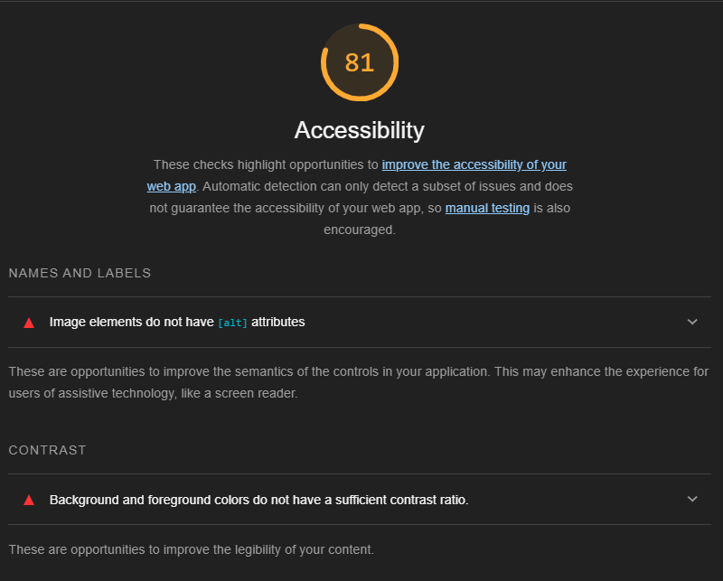

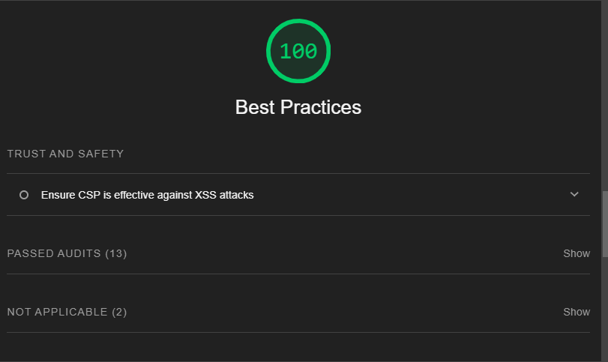

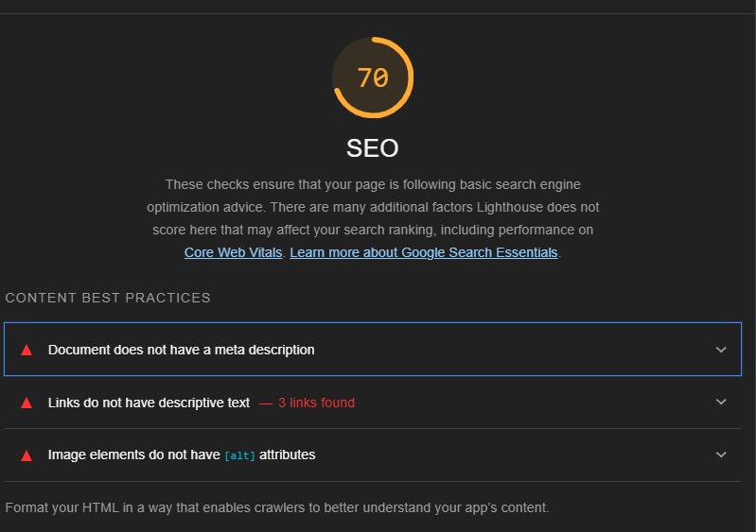

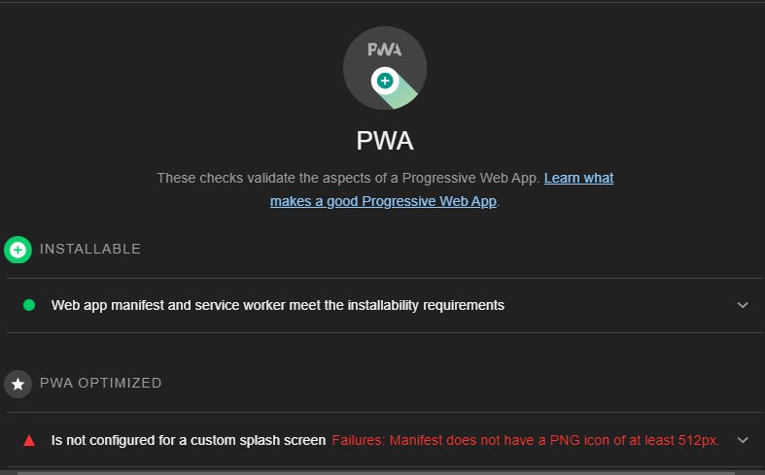

1. Wireframe

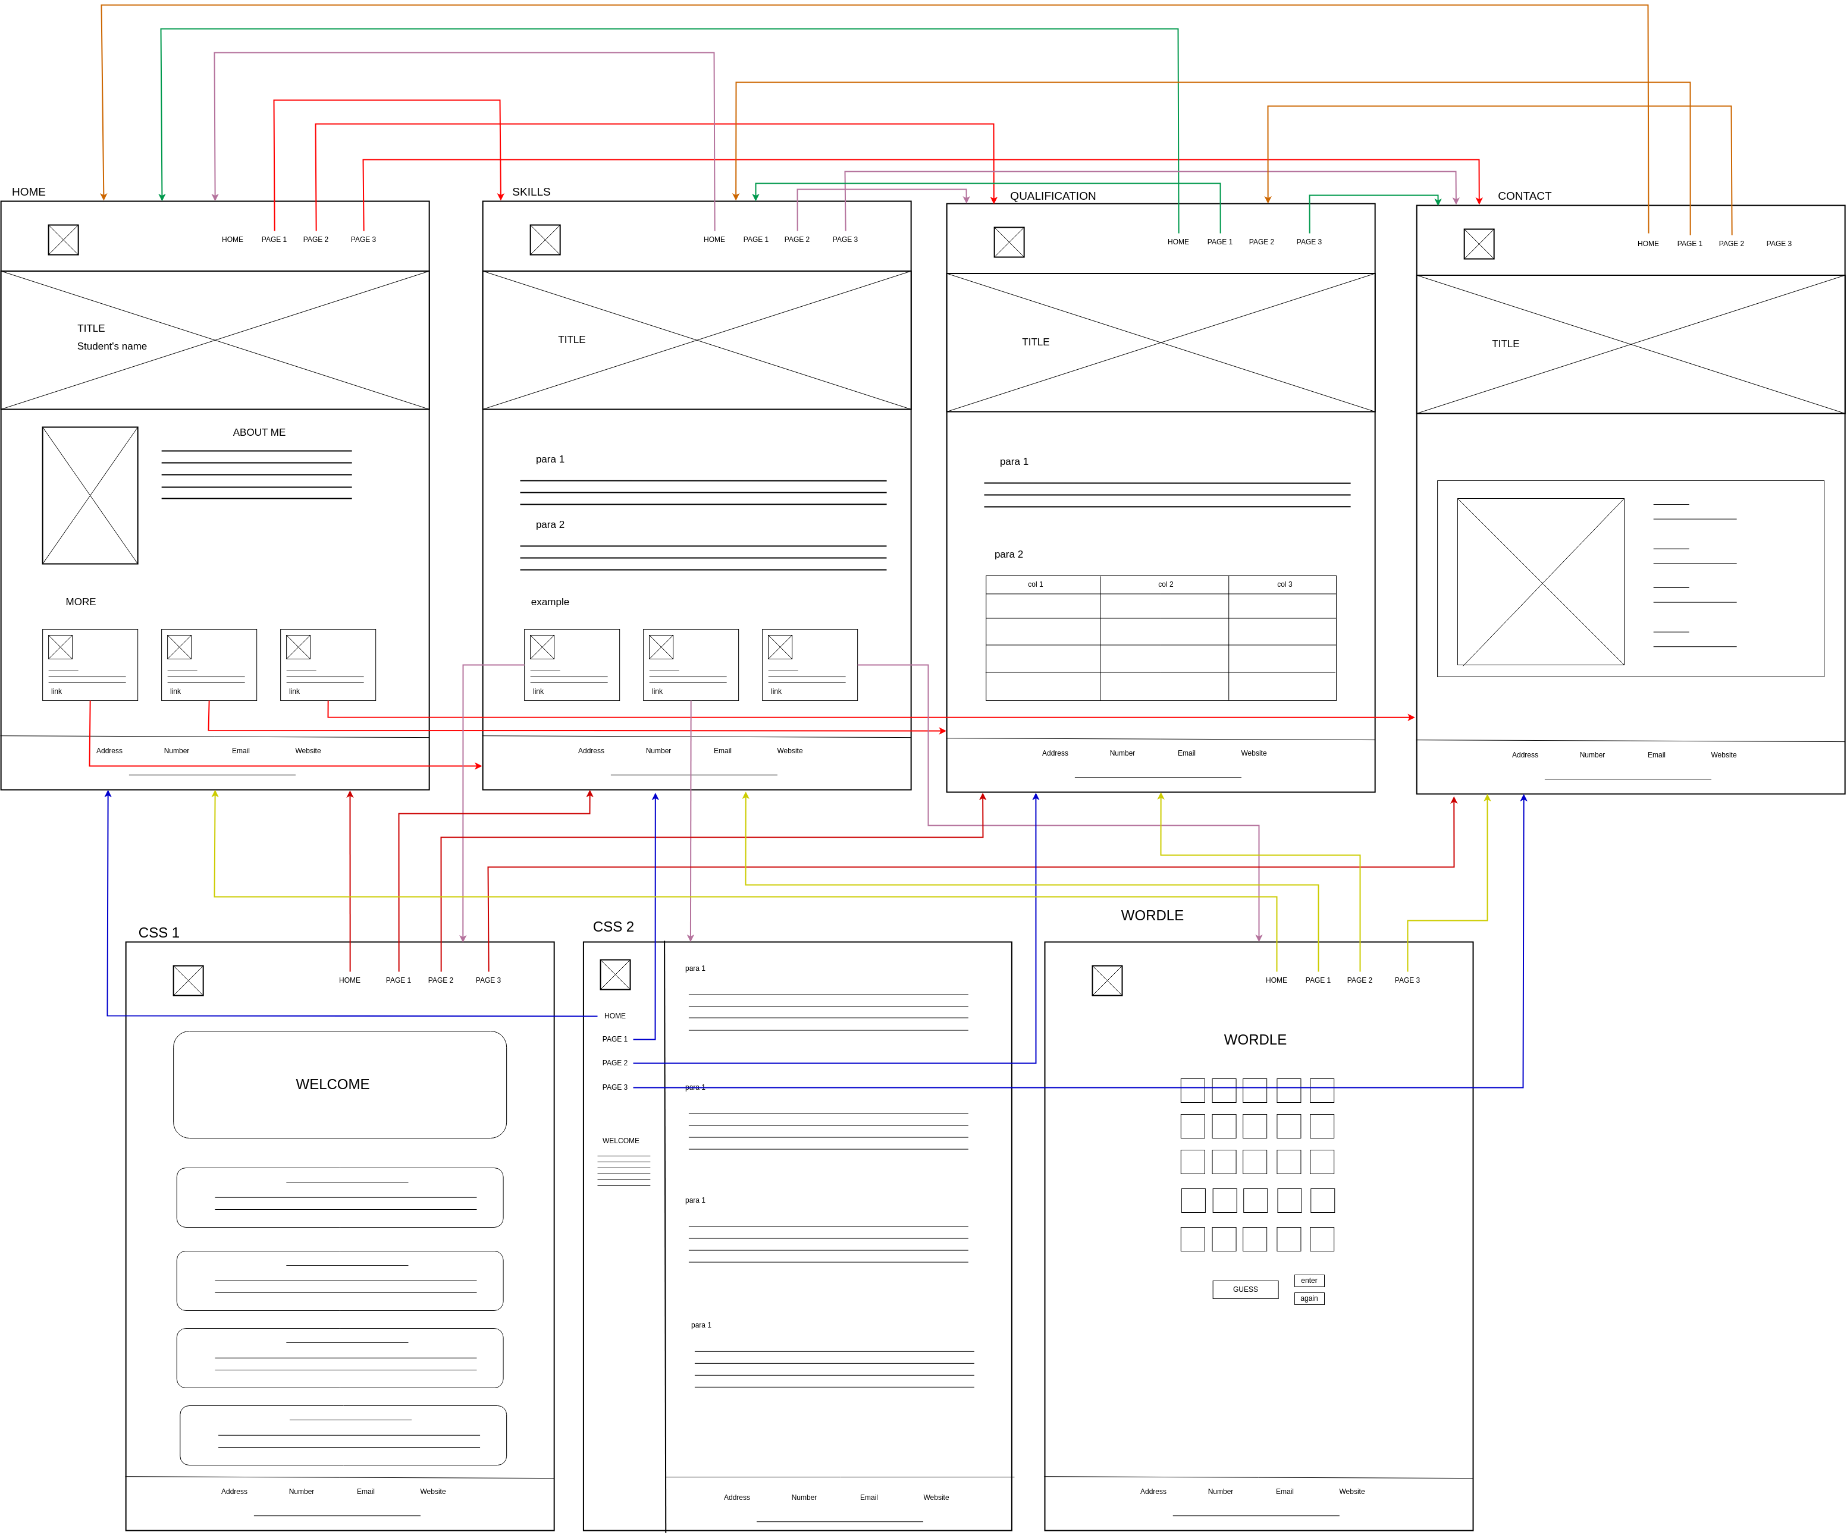

1. Activity diagram for Wordle

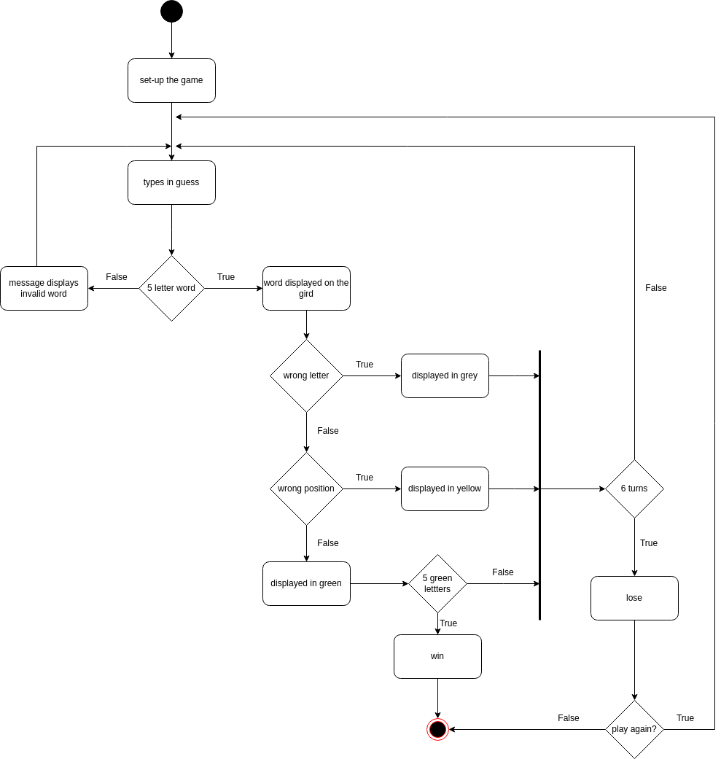

1. Wordle test plan

|  |  |  |  |
| --- | --- | --- | --- |
| **Input** | **Reason** | **Expected output** | **Actual output** |
| Input a guess | To test user input functionality | Correct letters and positions are displayed in the boxes | Correct letters and positions are displayed in the green boxes |
| Incorrect guess | To test feedback for incorrect guesses | Incorrect letters are highlighted | Misplaced letters are displayed with yellow boxes  Wrong letters are displayed with grey boxes |
| Invalid guess (less than 5 letters or more than 5 letters) | To test the input validation | The word will not be recorded, and a label will notify the user’s mistake | An appropriate message is displayed “Invalid word” |
| Game ends (win) | To verify winning conditions | Appropriate win message is displayed | An appropriate message is displayed “You win” |
| Click "Play Again” | To test game reset functionality | Game resets with a new random word | Game resets with a new random word, all previous recorded words disappeared |
| Click “Enter” | To test game enter functionality | The valid word will be displayed in the boxes | The valid word is displayed in the boxes |
| User enters numbers, special characters | To test the input validation | The word will not be recorded, and a label will notify the user’s mistake | The word is not recorded, and a message will notify the user’s mistake |